Central Tilba School

Newsletter

THURSDAY, NOVEMBER 24TH, 2011 - TERM 4, WEEK 7
Central Tilba Public School 89 Corkhill Drive Central Tilba NSW 2546
phone 02 4473 7210 fax 02 4473 7469
e-mail centrtilba-p.admin@det.nsw.edu.au website www.centrtilba-p.schools.nsw.edu.au

Dear parents and students
The primary class returned from Canberra yesterday after three days of exploring and learning about our national capital. During that time they visited Cockington Green, Old and New Parliament Houses, The Dinosaur Museum (by torchlight at night!), The War Memorial, The Australian Institute of Sport, Questacon and on Tuesday night we all went Ice Skating.
Needless to say, by the time we climbed on the bus to travel home, there were some tired and weary students (and one teacher as well!). I would like to thank Keira’s mum, Skye, who came with us for the trip and was a tremendous help, and Linda and Denise who put together the three days with a thousand phone calls and emails!
Finally, thank you to the students, who responded well to the rigorous schedule and who behaved well throughout the excursion. It has been a great aide to our HSIE studies this term on Government, and a great way for children to learn to live and get on with each other. (And it was also a lot of fun!!).
Last Friday the annual Gulaga Learning Community Public Speaking Day was held at our school. Congratulations to Charli, Tom, Luka, Nicholas, Tayla and Meg who spoke so well during the day. Charli was awarded runner up in the Stage 2 section (with Tom third and Luka fourth) while in the Senior group Nicholas was also runner up (with Tayla third and Meg fifth). The Public Speaking shield was won by Narooma with Tilba finishing a close second from Bermagui and Bodalla. Many visiting parents commented on our beautiful school and the quality of our speakers. Well done also to the members of the class who helped with time keeping and announcing.
Finally, our School Counsellor, Mr Steve Perry, was due to visit today, but due to unforeseen circumstances, will not be here until next Thursday, December 1st.
John Carter
Principal

INFANTS HOME READERS
Some readers are missing from our home reader sets. If you have any extra readers at home could you please return them to school as soon as possible.

KINDERGARTEN CLASS 2012
Our new Kindergarten class for 2012 will start on 30th January. The first week will be half days starting at 9.00am until 12.30pm. They will need to bring some fruit for fruit break each morning and lunch and a drink.

REMINDERS

SPECIAL LUNCH DAY ORDERS
Please have these returned by Wednesday 30th November.

ORIENTATION DAYS KINDERGARTEN CLASS 2012
The Orientation days set down for our Kindergarten Class of 2012 are THURSDAYS, DECEMBER 1ST AND 8TH , 9AM TO 1PM.

YEAR 6 ORIENTATION DAY NAROOMA HIGH SCHOOL
Full day orientation will be on Thursday 1st December 2011 from 8.55am to 3.25pm. Lunch will be provided for all students on this day. They need to wear covered shoes and should bring a pencil case and note pad.
A parent information evening will be held from 6.30pm on Thursday 8th December.
Please contact the high school on 44764377 if you require more information.

CAROLS AT BERMAGUI
CAROLS AT BERMAGUI
The Central Tilba students have been invited to join in the singing at the Bermagui Community Carols evening on Friday, December 9th, at the Dickinson Oval (or Surf Life Savers Club if raining), beginning at 5.30pm. Santa arrives at 7.30pm
It will be up to parents to take children to the event.
Louise will run the children through the carols at school prior to the event. These will include ‘Away in a Manger and ‘Three Kings Calypso’. Please let the school know if you have any objections to your child singing these carols at school.
Thank you .. Louise Hankinson
CAROLS AT BERMAGUI
The Central Tilba students have been invited to join in the singing at the Bermagui Community Carols evening on Friday, December 9th, at the Dickinson Oval (or Surf Life Savers Club if raining), beginning at 5.30pm. Santa arrives at 7.30pm
It will be up to parents to take children to the event.
Louise will run the children through the carols at school prior to the event. These will include ‘Away in a Manger and ‘Three Kings Calypso’. Please let the school know if you have any objections to your child singing these carols at school.
Thank you .. Louise Hankinson
The Central Tilba students have been invited to join in the singing at the Bermagui Community Carols evening on Friday, December 9th, at the Dickinson Oval (or Surf Life Savers Club if raining), beginning at 5.30pm. Santa arrives at 7.30pm.
CAROLS AT BERMAGUI
The Central Tilba students have been invited to join in the singing at the Bermagui Community Carols evening on Friday, December 9th, at the Dickinson Oval (or Surf Life Savers Club if raining), beginning at 5.30pm. Santa arrives at 7.30pm
It will be up to parents to take children to the event.
Louise will run the children through the carols at school prior to the event. These will include ‘Away in a Manger and ‘Three Kings Calypso’. Please let the school know if you have any objections to your child singing these carols at school.
Thank you .. Louise Hankinson
It will be up to parents to take children to the event.
Louise will run the children through the carols at school prior to the event. These will include “Away in A Manger and King Calypso”. Please let the school know if you have any objections to your child singing these carols at school.
Thank you
Louise Hankinson
CAROLS AT BERMAGUI
The Central Tilba students have been invited to join in the singing at the Bermagui Community Carols evening on Friday, December 9th, at the Dickinson Oval (or Surf Life Savers Club if raining), beginning at 5.30pm. Santa arrives at 7.30pm
It will be up to parents to take children to the event.
Louise will run the children through the carols at school prior to the event. These will include ‘Away in a Manger and ‘Three Kings Calypso’. Please let the school know if you have any objections to your child singing these carols at school.
Thank you .. Louise Hankinson
CAROLS AT BERMAGUI
The Central Tilba students have been invited to join in the singing at the Bermagui Community Carols evening on Friday, December 9th, at the Dickinson Oval (or Surf Life Savers Club if raining), beginning at 5.30pm. Santa arrives at 7.30pm
It will be up to parents to take children to the event.
Louise will run the children through the carols at school prior to the event. These will include ‘Away in a Manger and ‘Three Kings Calypso’. Please let the school know if you have any objections to your child singing these carols at school.
Thank you .. Louise Hankinson

Community Notice Board

Please note: the NSW Department of Education and Training does not endorse any product or service advertised in this newsletter.

KID’S FISHING WORKSHOP - BERMAGUI CONCERT

Tuesday December 20th Apex Reserve Narooma. Children 8 to 14 years are invited to come and learn to fish safely and responsibly. The day runs from 10am to 2pm and involves fishing techniques, bag and size limits, fish handling for catch and release. Cost $40 per child includes rod and reel combination, shirt, hat, tackle box and show bag – all to take home. Bookings essential – only 25 participants. Contact Stephen Thurston at Primary industries on 0242951809 or 0438245190.

JUNIOR FISHING CLUB

Players are excited to be returning to Bermagui again this December for another concert of wonderful music. The Ensemble is made up of professional and pre-professional musicians from the Canberra region, including some from the Far South Coast. On the program this time are works by Vivaldi, Bach and Dvorak all brought to life with joy, passion and sensitivity by this exciting chamber group. CCO Chamber Players tours are a wonderful opportunity to see and hear a high quality chamber orchestra in our area. Sunday 11th December at 2pm at BERMAGUI COMMUNITY HALL. 11am-2pm. Tickets $25 Concession $20. For more information or bookings please call 0413 506 311.

The Narooma Sports and Game Fishing Club

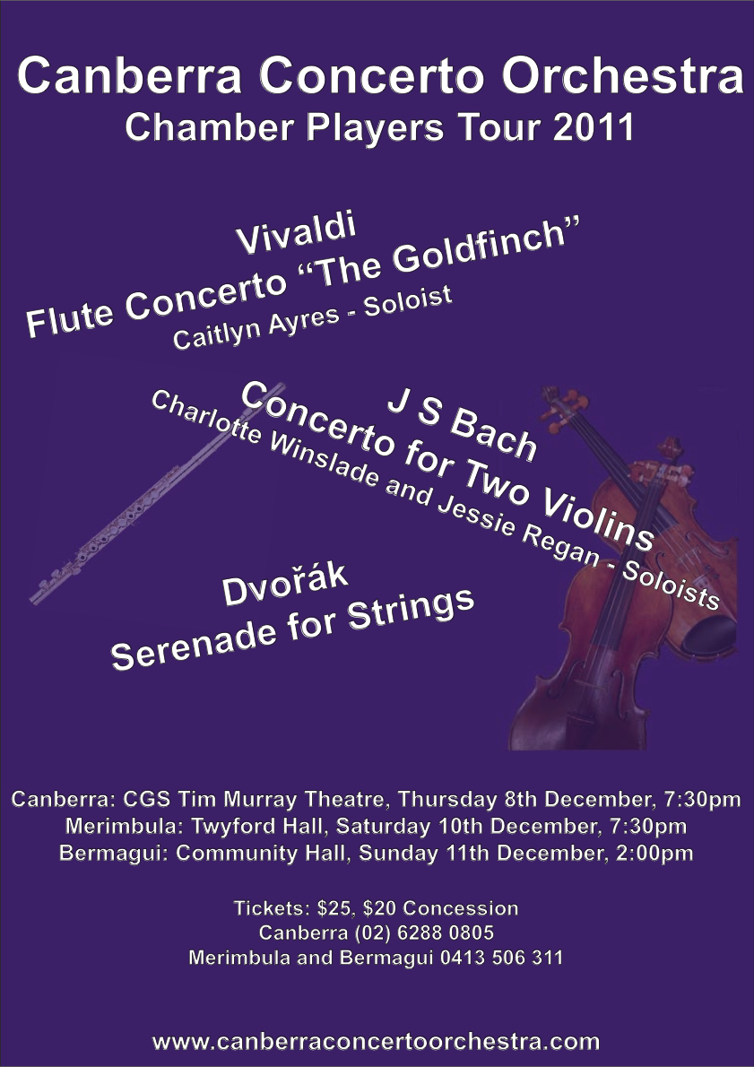
will be conducting a junior clinic at the clubhouse, Riverside Drive Narooma. All tackle and lunch supplied. Wednesday January 11th. Cost $15 per child, includes Shimano 6ft combo, small tackle box plus terminal. Start 9.30am to 2.30pm. Contact Barry Robertson after 5pm on 44737367 or 0405483852.

.

CHILDCARE ASSISTANTS WANTED!

Must be 18 years of age or over.
Must hold current First Aid Certificate.
Have demonstrated interest in and enjoyment/understanding of children aged 5-12 years.
Must have enthusiasm, energy and initiative.
Must be available to work some or all of the summer holiday period (21 Dec 2011 to 26 Jan 2012).
Male and female assistants required.
Please send email application/resume to:
Moruya@recruitflex.com.au
ASAP
or phone 4475 6081 for enquiries.

EFA Soccer Trials

Developement Squad selection trials to be held at Gundary Oval Moruya Friday 25th November and Friday 2nd December from 6.00pm to 8pm.
If you can’t make the first trial, please come to the second!

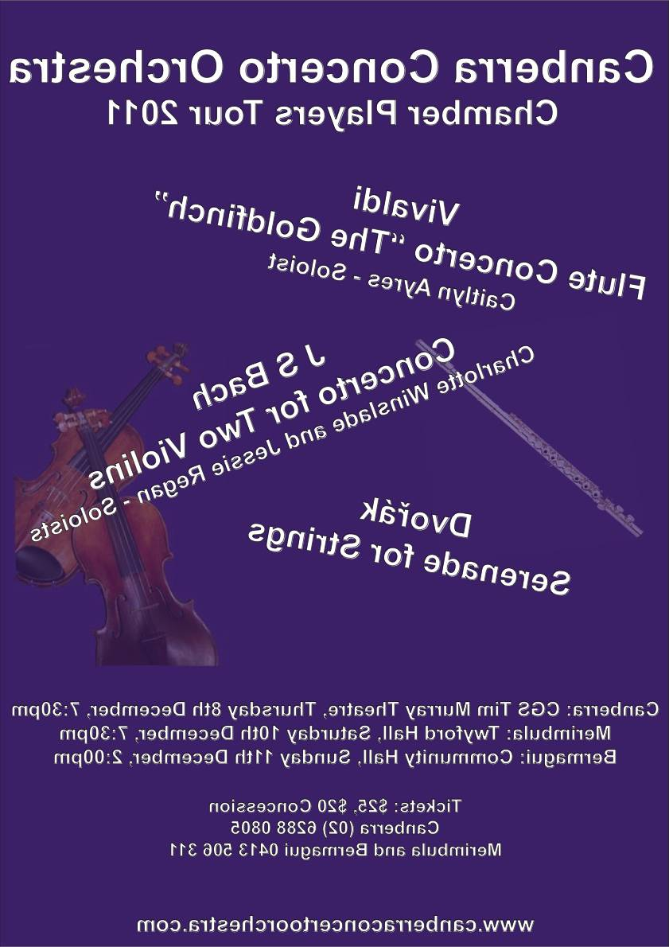
Special Lunch Day !

Friday 2nd December

Many thanks to all the parents who volunteer to help with the SLD or provide a dessert- it is very much appreciated.

Please remember to have your order in by Wednesday 30th of November so the shopping can be done to cater for the number of orders we have. Thank you muchly.

NAME(S):

ITEM | CHILD’S NAME  IF MORE THAN ONE CHILD | ITEM COST | QTY | TOTAL
Home Made Sausage Rolls  Tomato Sauce YES NO |  | $2.00
Curried Egg Sandwich |  | $2.00
Vegie Sticks and Homemade French Onion/Sour Cream Dip |  | $1.00
Grape Juice |  | $1.00
Tropical Juice |  | $1.00
Fran’s Chocolate Cookie Men |  | $0.50
Banana Cup Cakes |  | $0.50
TOTAL AMOUNT ENCLOSED |  |  |  | $

